**PHASE - 4**

**Big Data Analysis with IBM Cloud Databases**

**INTRODUCTION:**

In this phase of our project, we're diving deeper into our big data analysis solution. This stage involves the application of advanced analysis techniques to extract valuable insights from our dataset. Depending on the nature of our data and the specific objectives, we'll leverage complex methods such as machine learning algorithms, time series analysis, or sentiment analysis. To convey our findings effectively, we'll employ visualization tools like Matplotlib, Plotly, or IBM Watson Studio to create compelling graphs and charts. This multifaceted approach will empower us to unlock hidden patterns and trends within our data, enabling more informed decision-making.

**COMPLEX ANALYSIS TECHNIQUE:**

**Time series analysis:**

**Importing Libraries:**

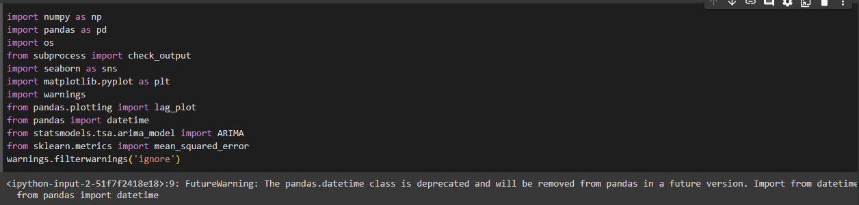

# Preprocessing:

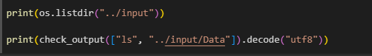

**Tesla Stock Market Analysis:**

# a.Import dataset and display the head of the dataset.

# 

# b.Display the shape and columns that is present in the dataset.

# 

# c.Display the closing price of the dataset.

# 

# d.Display the tesla cumulative returns.

# 

# e.Display tesla open price autocorrelation plot.

# 

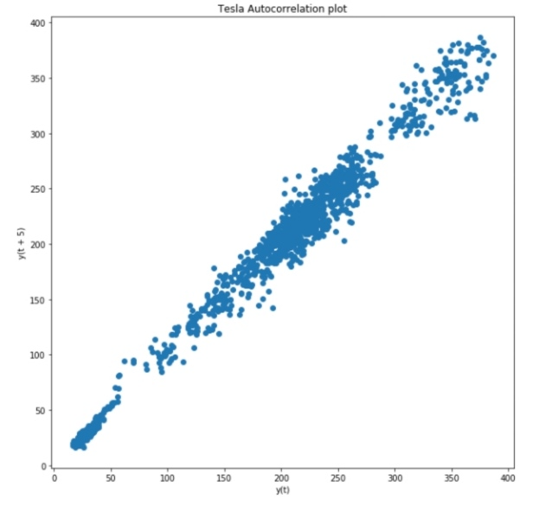

## **ARIMA (AutoRegressive Integrated Moving Average) for Time Series Prediction:**

**a.Tesla price prediction with training data.**

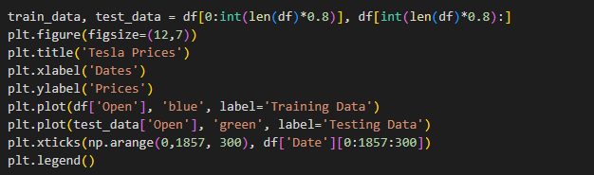

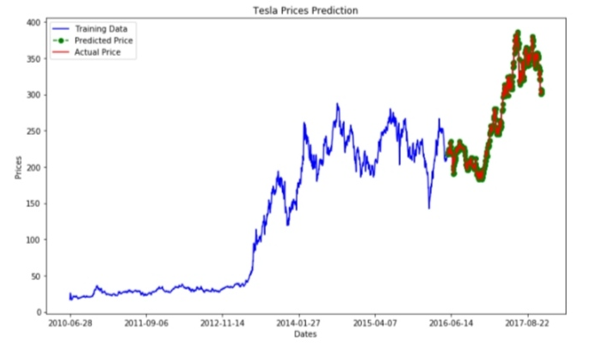

**b.Tesla prices prediction of actual and predicted values.**

